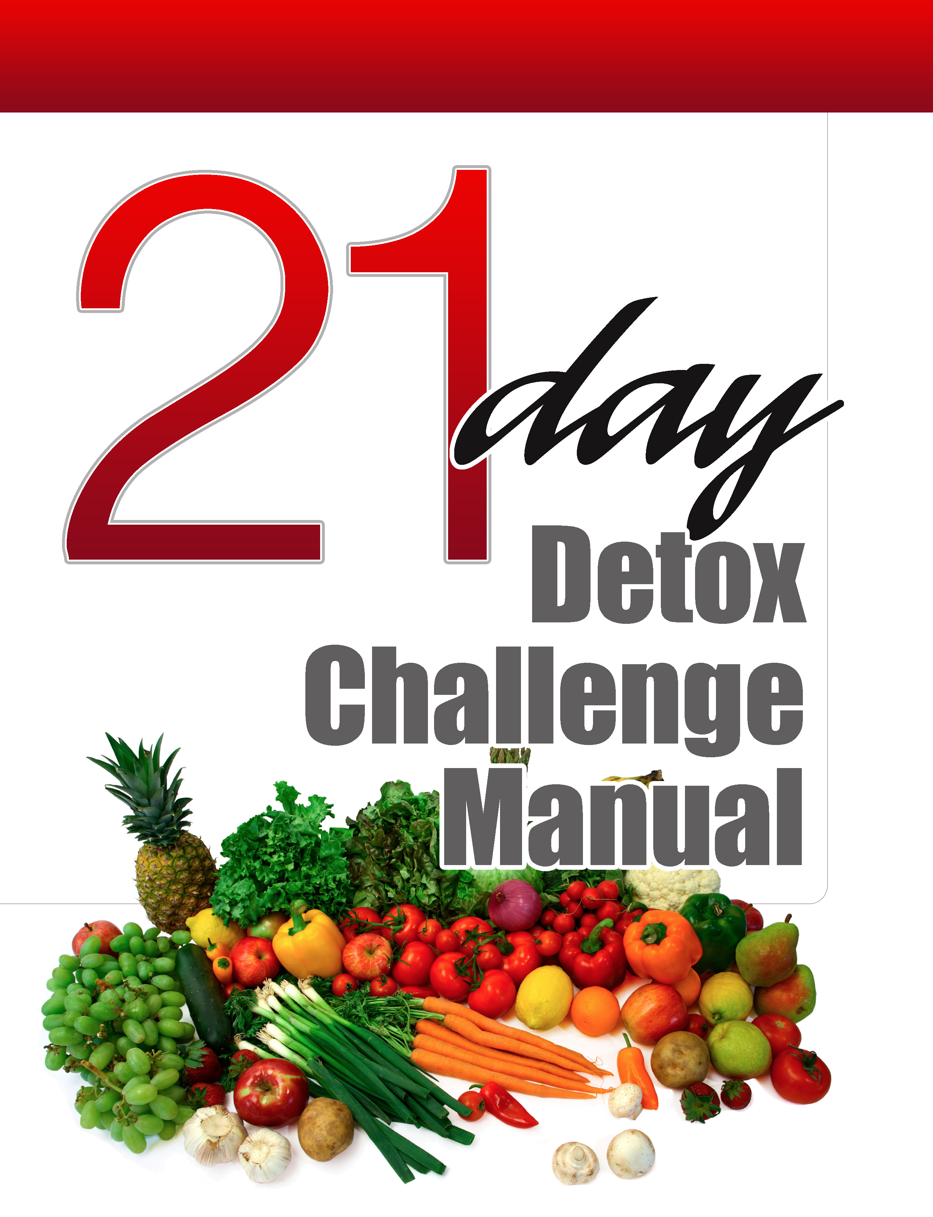
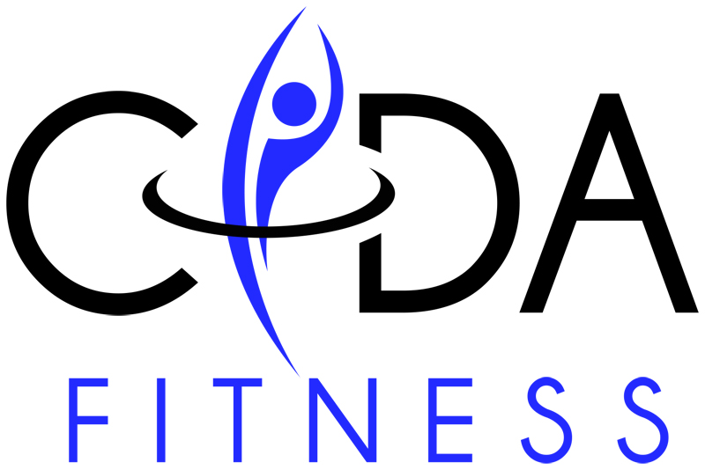

Disclaimer: This manual is not intended for the treatment or prevention of disease, nor is it a replacement for seeking medical treatment or professional fitness advice. Do not start any nutrition or physical activity program without first consulting your physician. The use of this program is at the sole risk of the reader. The author is neither responsible nor liable for any harm or injury resulting from the use of this program.

No portion of this manual may be used, reproduced or transmitted in any form or by any means, electronic or mechanical, including fax, photocopy, recording or any information storage and retrieval system by anyone but the purchaser for their own personal use. This manual may not be reproduced in any form without the express written permission of Cida Fitness, except in the case of a reviewer who wishes to quote brief passages for the sake of a review written for inclusions in a website or other media – and these cases require written approval from Cida Fitness prior to publication. For more information, please contact:

Louis Moore, M.S.
Cida Moore
www.cidafitness.com

21-Day Detox/Elimination

Over the course of the next 21 days you are going to challenge the way you are eating and what you have always considered a “healthy” diet. Your relationship with food and how your body and metabolism respond to the food you are eating will shift. You will have more energy, better mood, improved sleep, less gastrointestinal stress, and lose weight among other benefits. You may notice that symptoms such as bad breath, bloating, gas, constipation, or diarrhea, canker sores, difficulty concentrating, excess weight or difficulty losing weight, fatigue, fluid retention, food cravings, headaches, heartburn, joint pain, muscle aches, puffy eyes & dark circles under the eyes, postnasal drip, sinus congestion, skin rashes, and sleep problems improve or simply disappear.

Changing the foods that you eat may also help to fight more serious conditions such as: arthritis, asthma & allergies, autoimmune diseases, chronic fatigue syndrome, diabetes, high blood pressure, high cholesterol, obesity, acne, eczema, fibromyalgia, food allergies, headaches, heart disease, Crohn’s, irritable bowel syndrome, menopausal symptoms, and menstrual problems. Food is medicine and medicine is food!

The food you eat either makes you more healthy or less healthy.
Those are your options.
–It Starts with Food

Why Detox? Toxicity & Inflammation

Decreasing toxicity and inflammation is the key to effective, long-term weight loss. The goal of this program is not weight loss; it is improved health and identifying the underlying cause of why you may be overweight, carrying excess weight, or presenting with symptoms listed above. Weight loss is simply a side effect and benefit to reducing toxicity and inflammation in the body. Getting and being healthy is the key to losing weight. By taking away the foods in your diet that are causing toxicity and inflammation it gives your body a chance to reset.

Sources of toxicity in your life may be: addictive habits such as coffee, sugar, alcohol, processed food, fast food, junk food, trans fats, and high-fructose corn syrup. Sources of inflammation include: food allergens (gluten, dairy, soy, corn), sugar & flour products, bad fats, and alcohol.

What is Toxicity?
The toxic load on our body comes from our diet, chronic stress, and our environment. A diet high in sugar, trans fat, food additives & preservatives, pesticides, hormones, and antibiotics is very toxic to our bodies and our minds. Mercury, lead, and other heavy metals also contribute to our toxic load. Negative thoughts, behaviors, and beliefs that increase our stress level are toxic.

Toxins can be both external and internal. External toxins include chemical toxins and heavy metals. Chemical toxins are most commonly found in cleaning products, personal care products, pesticides, herbicides, and food additives. The Standard American Diet (S.A.D.) puts a tremendous burden on our bodies’ ability to detoxify naturally. Internal toxins include the waste products of bacteria, yeast, and other microbial organisms. This can interfere with normal metabolism as well as increase inflammation and oxidative stress.

Increased toxic load can affect weight loss attempts by: impairing two key metabolic organs (the liver & thyroid), damaging the mitochondria (the site of energy metabolism), harming brain neurotransmitter and hormone signaling that affects our appetite, and increasing inflammation and oxidative stress, both of which promote weight gain.

What is Inflammation?
Being inflamed makes you fat and being fat makes you inflamed!

Inflammation comes from the sugar we eat, high doses of the wrong kinds of oils and fats in our diet (omega 6&9 vs. omega 3), hidden food allergies, lack of exercise, chronic stress, hidden infections, and our fat cells. This low-grade chronic inflammation that you cannot see or feel leads to every one of the major chronic diseases: heart disease, cancer, diabetes, dementia, and more.

Part of doing an elimination diet is to identify foods that you are eating that could be the cause of chronic health and weight problems. The idea is to give your body a break from common food allergies/sensitivities and see if you lose weight and your symptoms get better/disappear. The type of food allergy I am referring to has a delayed response, anywhere from a few hours or a few days after ingestion.

Food allergies can play a HUGE part in chronic disease and weight problems but are not recognized by conventional medicine. Food allergies can cause: bloating, food cravings, reflux, trouble sleeping, autoimmune disorders, weight gain, fluid retention, fatigue, brain fog, irritable bowel syndrome, mood problems, headaches, sinus and nasal congestion, joint pains, acne, eczema, and more.

We develop food allergies when the lining of our gut and the balance of normal gut flora get damaged from poor diet, stress, medications, infections, or toxins. This is referred to as leaky gut. Partially digested food particles then enter our blood stream and the body attacks these foreign molecules creating immune response/complexes against them. This immune response increases the inflammation in our body. Healing your digestive system and the lining of your gut can reduce the severity and number of food allergies.

The food we eat should promote a healthy psychological response, promote a healthy hormonal response, support a healthy gut, and support immune function and minimize inflammation.

Healthy Psychological Response
Sugar is a drug!!! Nutrient-poor, high sugar, salty, carbohydrate dense foods are addicting and alter our pleasure, reward, and emotion pathways in the brain. Wheat actually binds to opiate receptors in the brain! Chronic stress and lack of sleep just reinforce and make this worse. What foods do you “crave” when you are stressed or running on little sleep? Foods rich in carbohydrates because they will increase serotonin, our “feel good” hormone. We then over eat these “Frankenfoods” (high sugar, high trans fat, high preservative unnatural processed foods) because we never reach satiation due to their lack of nutrients. Eating delicious food with the nutrition and satiety that nature intended is the solution to this problem.

Promote A Healthy Hormonal Response
It all comes back to managing blood sugar. Managing blood sugar will decrease the amount of insulin in the blood stream. Insulin is always present in the blood stream; the key is not having too much. Each time we eat we are telling our body to burn fat or store fat based on what that meal is made up of (protein, fat, carbohydrates). If insulin levels are high your body will not use fat for a fuel source and has a hard time stabilizing blood sugar.

Hormonal imbalance starts when you over consume carbohydrates. Over consumption of carbohydrates also leads to excess glucose and triglycerides in the blood stream promoting leptin resistance in the brain. Leptin is an important hormone that tells your brain you are full. Leptin resistance means that your brain is not hearing the leptin message and thinks you are starving. This promotes overeating and a decrease in your metabolism. Leptin resistance also promotes insulin resistance leading to chronically elevated blood sugar and insulin levels.

Cortisol is our stress hormone. Chronically elevated cortisol levels increase blood sugar because our body is in “fight or flight” mode and thinks we need the energy to run from the stressful situation. The elevated blood sugar levels can contribute to insulin resistance and promotes belly fat.

Support A Healthy Gut
Your gut houses about 60% of your immune system, makes melatonin & serotonin, as well as being a critical part of the digestive process. If your gut is not healthy, you are not healthy. Our gut is also home to about 3-5 pounds of bacteria, some healthy and some not so healthy. The balance of good and bad bacteria in our gut will affect our metabolism, psychological well being, and immunity. I mentioned earlier several external factors that can compromise and damage our gut. Visceral fat (the deadly kind that builds up around our organs) is one of the direct effects of increased gut permeability. Much like your hormones your gut health can be restored over time with the proper changes to nutrition, exercise, and lifestyle.

Support Immune Function and Minimize Inflammation
We have already talked about sources of inflammation and the effects of chronic low-grade inflammation in the body above. I wanted to mention one more thing about our immune system. If our immune system is always working and never gets a break it has a hard time doing it’s main job (fighting off acute inflammation), then something is going to not get done. That can include fighting off that bug that is going around, healing stubborn tendonitis, or keeping your arteries clear of plaque.

The Program

What to Avoid?

Grains: This includes wheat, pasta, rye, barley, oats, corn, rice, millet, bulgur, sorghum, amaranth, buckwheat, quiona, and sprouted grains

Sugar: No maple syrup, honey, agave nectar, Splenda, Equal, Nutrasweet, xylitol, etc. You must read labels because food manufactures will sneak sugar into products with names you may not recognize such as brown rice syrup or evaporated cane juice. Stevia is okay.

Alcohol: Not even for cooking, also eliminate any tobacco products.

Caffeine: No coffee; you can and should have green tea.

Legumes: This includes beans of all kinds: (black, red, pinto, navy, white, kidney, lima, fava, etc), peas, chickpeas, lentils, and peanuts. No peanut butter. This also includes all forms of soy – soy protein, soy sauce, miso, tofu, tempeh, edamame, and soy lecithin.

Dairy: Including cow, goat, or sheep’s milk products such as cream, cheese, kefir, yogurt, and sour cream. The exception is ghee (clarified butter)

Food Additives: carrageenan, MSG, or sulfites.

Protein Powder: Most protein powders are made with cheap whey (which is dairy) or soy (which is never ideal), especially if purchased at big chain stores. Also, most have some form of sweetener. A whey-based protein powder may also spike your insulin levels, which is not good. When you are not doing the detox program, a high-quality whey-based protein powder that is organic and from grass-fed cows may be a good option for occasional use. Brands we recommend include Life Extension, Source Naturals, and Nowfoods.

What to Eat?

Vegetables: 6-9 servings per day (1 serving= ½ cup cooked, or 1 cup raw)
Asparagus, broccoli, bok choy, Brussels sprouts, cabbage, cauliflower, bell peppers, carrots, celery, cucumber, tomatoes, spinach, romaine lettuce, zucchini, sweet potatoes, yams, snap peas, green beans, yellow beans, string beans, eggplant, jicama, pumpkin, water chestnuts, onions.
NO WHITE POTATOES

Fruit: 1-2 servings per day
Apple, banana, blackberries, blueberries, cantaloupe, clementine, cranberries, grapefruit, grapes, honeydew melon, kiwi, lemon, lime, orange, papaya, peach, pear, pomegranate, plum, raspberries, strawberries, watermelon

Fat: FAT IS YOUR FRIEND
Olive oil, coconut oil, MCT oil, nuts & seeds, nut butters, ground flaxseed, avocado oil, avocadoes, almonds, macadamia nuts, hazelnuts, olives, ghee, coconut butter/manna, coconut milk, coconut (meat or flakes)

Quality Protein: Seafood (including but not limited to: salmon, shrimp, scallops, cod, crab), grass-fed beef, bison, lamb, elk, venison, eggs, chicken, turkey, duck, pheasant, pork, bacon, and bone broth. Of course, organic is always the best choice.

A superfood protein mix for breakfast containing at least 25 grams of protein, amino acids, green phyto-foods, red foods, fiber, enzymes, and probiotics. We recommend the following brands: MacroLife and Garden of Life.

Beverages: Water (consume half your body weight in PLAIN water/day), herbal teas, green tea

Seasonings: all fresh and dried whole or ground herbs and spices, low-sodium organic chicken, beef, or vegetable broth, black or white pepper, salsa, sea salt

Supplements:
Continue taking any current supplements. Other supplements we recommend are Vitamin C, Alpha lipoic acid, 5 HTP, Essential Amino Acids (EAA’s), Omega 3’s, and a superfood protein mix.
5 HTP and EAA’s can help to reduce sugar cravings.

When to Eat?

Pre-Workout: This is going to vary based on when you workout and what your body can handle. Focus on protein and fat and avoid lots of fruit or carb dense vegetables. A carbohydrate rich meal will increase insulin putting your body in a fat storing mode. Examples of a pre-workout “snack” would be: two hard boiled eggs, some turkey or chicken and a handful of macadamia nuts, or a few strips of beef jerky (can’t have added sugar). See picture below as a sample:

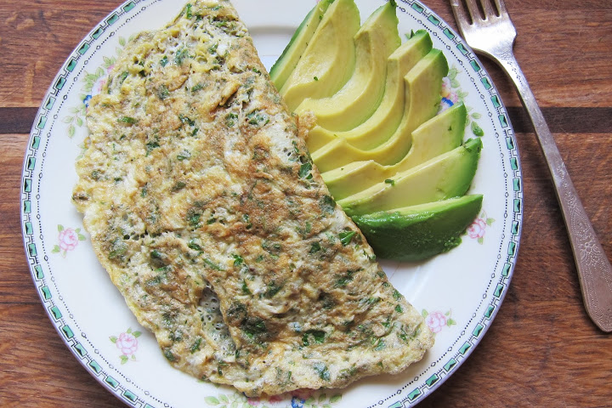

Also, you can drink a superfood protein mix around 60 minutes before the workout or after your workout. You can use a little bit of frozen fruit (1/2 cup of blueberries and/or strawberries), but don’t overdo it because too much fruit will cause your insulin levels to rise too much.

Post-workout: Eat within 30 minutes of training. Have a serving of protein with some starchy vegetables. Fruit is not your best option here. Examples of a post-workout meal include: chicken breast and sweet potato, salmon and butternut squash, or egg whites mixed into mashed pumpkin. Eat a normal meal sixty to ninety minutes after your post workout meal.
You only need a post workout meal if performing high intensity interval training, strength training, or longer duration cardiovascular exercise. If you are walking or doing gentle yoga you don’t need to include a post-workout meal.

Note: The amount of carbohydrates to be consumed post workout is going to depend on your fat loss goals. If you are new to exercising and eating healthy and have a lot of body fat to lose just include protein in your post workout meal.

Meal Timing: Strive to eat 3 meals a day and avoid snacking if possible. This obviously changes on the days you engage in high-intensity exercise. You might also need to “break the rules” if you work exceptionally long days or have an exceptionally active metabolism. In that case you may end up eating 4 meals per day.

The main objective is to leave 4-5 hours in between meals to allow you digestive system to function properly as well as keep leptin levels normalized. Each meal should be designed to hold you over until the next, taking away your desire to snack. As your body starts to use more fat for energy you will experience less between-meal cravings, energy slumps, and brain fog.

Eat your breakfast (high-protein with fat) or superfood protein mix drink within 30 minutes of waking. Walk outside for around 15 – 30 minutes and look at the sun. The blue, purple, and especially the red ultraviolet rays of the sun will re-energize the hormone melatonin, which will enable a higher amount of this hormone to be released at night for better sleep. Also, the light rays will help reset your leptin hormone to be able to send and receive the critical signaling message to your hypothalamus in your brain that you are full and content after a meal. This is key because most people have their leptin signaling off-track causing problems with weight management. And finally, consistent exposure to the sun and it various rays in the morning on a daily basis (just 15 – 30 minutes will do the trick) can significantly boost Vitamin D3 and dopamine levels. Remember, dopamine is the neurotransmitter responsible for your initiative, ambition, and desire to do things (you won’t be able to complete this detox program or any other type of fitness program for that matter without sufficient amounts of dopamine). I realize a lot of this information in this paragraph may sound a little “woo-woo,” but trust me, there is a lot of research and literature to support it. It’s a field of health called circadium mitochondria biology.

In general avoid snacking between meals as this can disrupt the normal functioning of leptin, insulin, and overall you may end up eating more. It will take you some time to gauge how much and what the right types of foods to eat at each meal are. I am still working on it. So, in the case that you maybe didn’t eat enough at one particular meal or not enough fat to keep you satisfied instead of getting cranky, tired, or hungry have a snack that is protein and fat based. Don’t just snack on veggies or fruit alone. Examples would include: 2 hard-boiled eggs & veggies, celery & nut butter, or chicken/turkey and vegetables.

Eat your lunch around 12;00 pm – 1:00 pm and stick to the recommendations in the sample menu below. Dinner will be around 6:00 pm – 7:00 pm, which should correspond with the timeframe close to sunset. Don’t eat dinner late at night.

Lifestyle Modifications

Exercise: Continue with your current exercise routine. You may also choose to add in a couple of short 10-minute walks each day or one 30-minute walk per day. Getting outside and connecting with nature, sunshine, and movement can help us reduce stress and improve our well-being. This might also be a good time to add in some stretching or yoga into your current routine.

If you are not currently exercising you may consider adding in a 30-minute walk each day, stretching, or yoga.

Journaling: This may help you keep track of your progress and experience during the detox. Journaling can be a powerful technique for identifying what is important to you and finding some inner guidance. More often than not, you are stronger and smarter than you give yourself credit for. Studies have also shown that journaling reduces stress and inflammation and can have a profound impact on health.

Here are some examples of questions to ask yourself while journaling:
- What can I do today to take care of my body?
- What am I willing to let go of today that is no longer serving me?
- How do I feel today? Physically, mentally, emotionally
- What am I grateful for today?

Detox Bath: MY FAVORITE
Aim to take a detox bath 2-3 times per week. Get the water as hot as you can stand it. Add 2 cups of Epson salt, 1 cup of baking soda, and 10 drops of lavender to the water. Soak for 20 minutes prior to bed.

Benefits of the detox bath include:
- Decreasing cortisol levels which promotes weight loss and lowers inflammation
- Increased detoxification through the effects of the magnesium and sulfur in the Epson salts.
- Enhanced sleep through the effects of the hot bath and magnesium.
- Lowered blood pressure and blood sugar levels.
- Increased sweating and elimination of toxins.
Environmental Toxins: Minimize toxic exposure to chemicals found in personal care and cleaning products. Pay special attention to these key products: perfume, deodorant, and toothpaste.
Avoid deodorants that contain aluminum. Choose toothpaste that is fluoride and chemical free.
The cosmetic dirty dozen includes: BHA&BHT, coal tar dyes, DEA, dibutyl phthalate, formaldehyde-releasing preservatives, parabens, parfum (fragrance), PEG compounds, petrolatum, siloxanes, sodium laureth sulfate, triclosan.
Stay away from BPA; a chemical in canned food liners and plastic food containers. Choose non-toxic cleaning products.

Getting Started

- Clean out your pantry and fridge: If the “bad” food is not in your house you won’t be able to eat it. Your family probably doesn’t need to be eating those processed foods you have committed to eliminating for 21 days either, but if that is not realistic then create a place for “YOUR” food. Have a special cabinet where you will be keeping all of your food and arrange your fridge so that any non-compliant foods are not within your sight.

- Plan One week of meals: “If you fail to plan, you plan to fail.” This is going to take some planning and organization. Figure out which nights you will home to cook dinner and which nights you need a quicker option (a go-to meal or something from the freezer). Then plan what you will make for dinner the nights you are home. Make sure you will have some leftovers for breakfast and lunch. Also make a plan for some breakfast and lunch options that are quick and easy. This will make creating your grocery list very simple.

- Grocery Shop: Stock your fridge with lean proteins, eggs, and fresh fruits and vegetables. You may need to shop more often to ensure that your meat and produce are fresh. Fill your pantry with cooking staples such as (coconut oil, almond meal, and a variety of spices).

- Establish “Go-To Meals”: Pick 2-3 meals that can be prepared in about 15 minutes on those nights that you get home late and don’t feel like cooking. Our favorite is breakfast for dinner, eggs, veggies, and bacon or pork sausage topped with avocado. Or I will pick up a rotisserie chicken from Whole Foods Market and pair with steamed veggies. If you don’t have any veggies prepped frozen is an option. My last tip/suggestion here is to cook several meals on the weekend and then freeze some. I have usually have chili, vegetable soup, and Chicken “noodle” soup in our freezer most of the time.

- Put together a Game Plan: What situations will you be faced with over the next 21 days? Traveling? Out to dinner? Family get together? If you have a plan going in you WILL be successful. You may have to be a little bit selfish in some of these situations. This program is absolutely do-able with all of these situations, it just takes some planning. Offer to cook or at least bring one dish that you know you can eat. If you will be eating out whenever possible take charge and pick the restaurant. Find a protein source and a vegetable; you may have to custom order, meaning create your own menu item. Plan ahead and bring your own dressing (olive oil, lemon juice, salt, & pepper).

Choose activities/events that are not centered around food. Meet a friend for tea, take a Zumba class, or get outside for a walk at your local park.

- Enlist your Support Team: Who will be your support system throughout this challenge? You always have the Cida Fitness team and members. Having a solid support team that will not sabotage your efforts is critical. You may choose to not spend as much time with those who you feel do not/will not be supportive of your during this time.

- Establish baselines: Fill out your symptom spreadsheet to establish a baseline. Complete your weigh-in and before picture at Cida Fitness. You may choose to take another picture at home as well. Then DO NOT get on the scale until you come to weigh-in again at Cida Fitness. This is CRITICAL! If you don’t think you are losing weight quickly enough you will be defeated and wonder if all of your efforts are worth it, THEY ARE! We all know the scale is not the only way to measure progress and success. BREAK UP WITH YOUR SCALE FOR 21 DAYS!

What to Expect

Days 1 to 7: How you feel at first will have a lot to do with your current diet and lifestyle. You will most likely feel worse before you feel better, BUT I promise you WILL feel better. The most common thing people experience is strong sugar cravings. Taking supplements such as 5 HTP and glutamine can help with this. Your body and brain are desperately trying to adapt to this new way of eating. Common symptoms are headaches, feeling like you have the flu, fatigue, and constipation. If constipation persists please let me know, as there are protocols to help with this. Once you get over this hump though you will have more energy than you know what to do with! You will most likely experience a change in your body because you are not bloated from the food you are eating.

Days 8-14: This is when you start to feel like you have more energy and are sleeping better at night. Remember a lot of the foods you are no longer eating have been wreaking havoc on your digestive system and it cannot heal overnight. You may still be experiencing GI distress such as: gas, bloating, diarrhea, or constipation. The digestive system can take months to heal but in the process cause some discomfort. You are likely eating more vegetables and fruit than you are used to which in itself can cause digestive issues. Try cooking all of your vegetables vs. eating them raw. Eat small servings of fruit throughout the day versus 1-2 big servings. If eating a lot of nuts for healthy fats that could be contributing to digestive upset. Switch to other fats like avocado, coconut oil, or olive oil.

Days 15-21: More than likely you have more energy, have more mental focus, are sleeping better, and symptoms that you had when you started have begun to disappear. By now your taste buds are starting to adapt and you are enjoying the flavors of the foods you are eating. If you have been relying on the same foods over and over again, change it up! Just because it has been 21 days DOES NOT mean you need to re-introduce potentially inflammatory foods or stop the program. You can and should continue to eat this way until the thing you most wanted to change at the beginning of the program has changed or gotten better. If you have been eating an inflammatory diet your entire life it is going to take longer than 21 days to see maximum results.

Now What?

1. Fill out the symptom spreadsheet.

2a. Continue the program. (this is not a bad way to eat for the long term)

OR

2b. End the Program, Reintroduce foods, and Keep Your Healthy Lifestyle

If you know that you feel better and WILL experience a reaction to gluten, dairy, etc. then it should go without saying…don’t reintroduce that food. JUST STAY AWAY FROM IT. That also goes for foods that you can now go without that you know are less healthy for you.

Reintroduction Process: It is VERY important that you do not go right back to eating the way you were before you started this program. If you do you will most likely feel worse than when you started and/or get VERY sick.

WHY? When you eliminate inflammatory foods that may be causing a reaction in your body the antigens these foreign particles produce dramatically decrease or drop-off. But the antibodies that have been created can take several months to be eliminated by the body. So when you eat bread or drink milk after having eliminating them these antibodies gang up on the foreign particles causing an inflammatory reaction.

You will reintroduce a different food group every 3 days. It is important to keep a log or journal of any symptoms you experience when reintroducing different foods. Symptoms can occur anywhere from a few minutes to 72 hours later. They include fatigue, joint pain, acid reflux, brain fog, mood changes, headaches, post-nasal drip, digestive upset (bloating, gas, constipation, diarrhea), sleep problems, rashes, joint pains, fluid retention, and more. Another way to track is to monitor your weight, if a food is inflammatory you will be retaining more fluid and that can make the number on the scale go up.

- Day 1: Dairy (cow, goat, & sheep): Keep everything else the same but eat 2-3 servings of dairy. An example would be to have cheese with your omelet at breakfast and Greek yogurt w/berries in the afternoon. If you have a reaction right away then stop eating dairy. You may need to cut it out completely for 3-6 months and then only eat it every 4-5 days. Or you may decide that how you feel after you consume dairy isn’t worth it to you and you choose to not eat it.
- Day 4: Gluten-containing grains: Keep everything else the same but eat 2-3 servings of gluten. A bagel for breakfast, sandwich for lunch, and pasta for dinner. Track how you feel after consuming gluten and decide if or how much you want it to be part of your nutrition plan. (I recommend not at all, the adverse effects just are not worth it!)
- Day 7: Non-gluten containing grains: Keep everything else the same but eat 2-3 servings of non-gluten containing grains. Have some brown rice or quiona, corn chips, and a slice of gluten free bread. Evaluate how you feel and how you look to decide, how often or if you will incorporate grains into your nutrition plan.
- Day 10: Legumes: Keep everything else the same but eat 2-3 servings of legumes. Have some peanut butter, lentil soup, and a side of black beans. Evaluate how you feel and look to decide, how often or if you will incorporate legumes into your nutrition plan.

Caffeine & Alcohol: These substances can be used from time to time but be cautious as they are drugs and need to be used moderately and wisely. Most individuals feel better and have more energy once they no longer have coffee daily. Regular use of coffee can increase your cortisol levels and deplete your adrenals over time. If you enjoy coffee like I do, cycling on and off is the best way to go: 6 weeks on, 2 weeks off, for example.
Alcohol may also be enjoyed in moderation, (1-3 drinks per week).

Resources Used To Compile This Manual Include:
- It Starts with Food by Dallas & Melissa Hartwig
- The Ultra Simple Diet by Dr. Mark Hyman
- Ultra Metabolism by Dr. Mark Hyman
- Cracking the Metabolic Code by Dr. Jim LaValle

Rating scale:
0=Never or almost never
1=Occasionally have it, effect is not severe
2=Occasionally have it, effect is severe
3=Frequently have it, effect is not severe
4=Frequently have it, effect is severe

Symptom | Before | After | Difference
Nausea or vomiting
Diarrhea
Constipation
Bloated Feeling
Belching or passing gas
Heartburn
Intestinal/Stomach pain
Mood Swing
Anxiety/fear, or nervousness
Anger, irritability, or aggressiveness
Depression
Fatigue or sluggishness
Apathy or lethargy
Hyperactivity
Restlessness
Watery or itchy eyes
Swollen, reddened, or sticky eyelids
Bags or dark circles under eyes
Blurred vision
Headaches
Faintness
Dizziness
Insomnia
Irregular or skipped heartbeat
Rapid or pounding heartbeat
Chest pain
Aches or pain in joints
Arthritis
Stiffness or limitation of movement
Aches or pain in muscles
Feeling of weakness or tiredness
Chest congestion
Asthma or bronchitis
Shortness of breath
Difficulty breathing
Poor memory
Confusion or poor comprehension
Poor concentration
Poor physical coordination
Difficulty making decisions
Stuttering or stammering
Slurred speech
Learning Disabilities
Chronic coughing
Gagging or frequent need to clear throat
Sore throat, hoarseness, or loss of voice
Swollen or discolored tongue, gum, or lips
Canker sores
Stuffy nose
Sinus problems
Hay fever
Sneezing attacks
Excessive mucus formation
Acne
Hives, rashes, or dry skin
Hair loss
Flushing or hot flushes
Excessive sweating
Binge eating/drinking
Craving certain foods
Excessive weight
Compulsive eating
Water Retention
Excess alcohol intake
Night Eating
Frequent illness

21-Day Detox Challenge
  - Sample Meal Plan Template

 | MONDAY | TUESDAY | WEDNESDAY | THURSDAY | FRIDAY | SATURDAY | SUNDAY
Meal 1 | Veggie Omelet | Superfood Protein Drink | Superfood Protein Drink | Hard Boiled Eggs & Raw Veggies | Superfood Protein Drink | Superfood Protein Drink | Superfood Protein Drink
MEAL 2 | Italian Pork Roast w/Kale-Brussels Sprout-Bacon Salad | Spinach Salad w/Rotisserie Chicken…  Dressing: Olive Oil, Lemon Juice, S&P | Hard Boiled Eggs, Raw Veggies, ½ Apple w/Almond Butter | Spinach Salad w/Canned Salmon  Dressing: Olive Oil, Balsamic Vinegar, S&P | Chicken “Noodle” Soup | Mexicali Beef & Cauliflower Rice | Super Bowl Sweet Potato Skins
MEAL 3 | Rotisserie Chicken, Roasted Root Veggies, Steamed Green Veggie | Lemon Dill Salmon, Green Veggie, Butternut Squash | Pot Roast w/Carrots, Mashed Cauliflower | Chicken “Noodle” Soup | Creamy Zucchini & Shrimp | Bacon Chicken Alfredo | Italian Pork Roast w/Kale-Brussels Sprout-Bacon Salad, Acorn Squash

Snack Options: If you feel the need for a snack between meals, first drink a large glass of water and wait 20 minutes. If you are still hungry, have a handful of nuts or a piece of fruit w/nut butter.

21-Day Detox Challenge
  - My Meal Plan Template

 | MONDAY | TUESDAY | WEDNESDAY | THURSDAY | FRIDAY | SATURDAY | SUNDAY
Meal 1
MEAL 2
MEAL 3

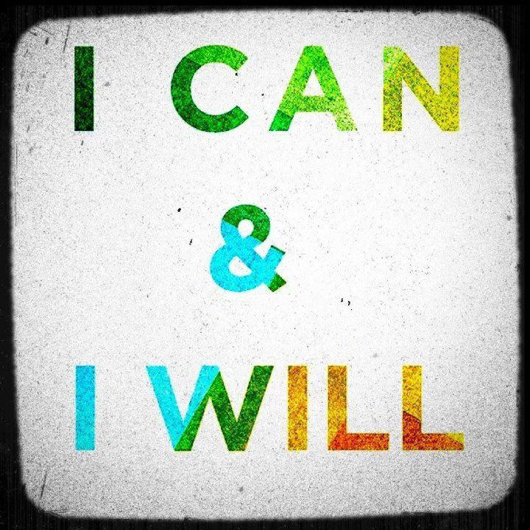

Almond Flax Chicken

Original Recipe from Ultra Simple Slimdown

Makes: 4 servings

Ingredients
4- 5 oz. chicken breasts
3 Tbsp ground flax
1/2 cup almond meal
1 Tbsp olive oil
1 Tbsp almond butter
1 tsp. lemon juice
1 tsp. sea salt
Pinch cayenne pepper
1 tsp parsley, fresh
1/4 tsp. paprika
1 tsp thyme, fresh
1 Tbsp onion finely chopped

Directions:
Pre-heat oven to 350 degrees.
Rinse the chicken and pat dry with paper towel. Take the chicken pieces and pound them evenly flat across the breast using a kitchen mallet or other heavy kitchen utensil.
Pour almond meal and flax into a small bowl and stir to mix evenly.
In another small bowl combine the olive oil, almond butter, lemon juice, and all spices and herbs. Mix in a small food processor or by hand. Once combined add the chicken breasts to this mixture (if time, allow the chicken to marinate with the mixture for 10-15 minutes to further enhance the flavor but the taste will still be great if you don't have an extra 10-15 minutes).

Remove chicken breasts from marinade bowl and place on baking tray. Sprinkle half of the almond/flax mixture evenly across one side of all 4 chicken breasts. Pat each chicken piece with hand to better adhere the "crust" to the chicken. Carefully turn over each chicken piece and repeat the process using the remaining half of the almond-flax mixture on the other side of the 4 chicken breasts.
Place tray with crusted chicken in center of the oven and bake for 20-30 minutes or until an instant thermometer reaches 168 degrees on the thickest part of the chicken.

Avocado Dressing
  - Original Recipe from Eat, Lift, and Be Happy

Ingredients

2 ripe avocados
- Juice of 1.5 limes
- 1/8 cup balsamic vinegar
- 1/8-1/4 cup water (more if necessary to reach desired consistency)
- About 4 sprigs of cilantro
- 1-2 tsp sea salt
- 1.5 tsp garlic powder
- Pepper to taste

Directions:

- Combine all ingredients in a food processor, and blend until smooth.
- If the dressing is not your desired consistency, add water, just a tsp at a time.
- Taste, and add more salt, garlic, etc if necessary.
- Place in an airtight jar and refrigerate for up to 10 days.

Baked Cod with Thyme
  - Original Recipe from The Ultra Simple Slimdown
Prep Time: 5 minutes
Cook Time: 15 minutes
Makes: 4 servings

Ingredients

1 ½ lbs. cod fillet
1 tsp. fresh thyme
½ tsp. sea salt
¼ tsp. onion powder
1 TBSP avocado oil

Directions

Pre-heat oven to 375 degrees.

Cut the cod into 5 oz. pieces.
Combine the avocado oil, thyme, salt, and onion powder in a bowl. Mix.

Cover cookie sheet or baking dish with parchment paper. Place cod fillets on baking pan.
Evenly spread the herb and oil mixture over the cod.

Bake for approximately 12-15 minutes or until fish flakes easily with a fork: internal temperature of the cod should be 155 degrees Fahrenheit.

Note: Fresh cod is the best but not always available. When substituting with frozen fish let the fish thaw completely in your refrigerator before cooking it.

Banana Nut Porridge
  - Original Recipe from Against All Grain
Yield: 4 servings

Ingredients

1/2 cup raw cashews
1/2 cup raw almonds
1/2 cup raw pecans
1 very ripe banana (makes it easier to digest plus adds a little more sweetness)
2 cup coconut milk
2 teaspoons cinnamon
Dash of sea salt for soaking water

Directions:
Place the nuts in a large bowl and sprinkle the sea salt over them. Fill the bowl with filtered water so the nuts are covered by at least 1 inch of water. Cover and soak overnight.
Drain the nuts and rinse 2 or 3 times, until the water runs clear.
Add the drained nuts to a food processor or high-speed blender. Blend the nuts with the banana, coconut milk, and cinnamon until smooth.
Divide it into bowls and microwave for 40 seconds or put all of the porridge in a pot on the stove and heat over medium-high heat for 5 minutes.
Serve with raisins, chopped nuts, and an extra splash of milk if desired.

Beefy Mexi “Cauli” Rice
  - Original Recipe from Healthy Living How To
Prep Time: 5 minutes
Cook Time: 15 minutes
Serves: 3-4

Ingredients
- 1 Medium to Large Head of Cauliflower (grated with a cheese grater)
- 1 lb. Grass Fed Ground Beef
- 14.5 oz. can of Organic Garlic & Onion Tomatoes (drained)
- 1 Heaping Tbsp. Chili Powder
- Garlic Salt to Taste
- 1 Medium Avocado

Directions
- In a skillet add grated cauliflower, ground beef & tomatoes.
- Cook on medium-high heat until beef is no longer pink.
- Add chili powder and garlic salt to taste.
- Turn heat to high to cook off liquid (optional).
- Top w/avocado and serve.

Brussel Sprout, Kale, and Bacon Salad
  - Original Recipe from Multiply Delicious
Yield: 6 servings

Ingredients

5 to 6 slices nitrate-free bacon
1 pound brussel sprout, trimmed and shredded
1 bunch of kale (about 3 cups), stems removed and shredded
1 teaspoon garlic, minced
Juice of ½ of lemon
Dash or two of red pepper flakes

Directions:
In a large non-stick skillet cook bacon a few slices at a time until cooked through. Once cooked set aside on paper towel. Do not disregard the nice bacon grease you have in your skillet.
Heat the same skillet you cooked the bacon with (and still has the bacon grease) over medium-high heat. Add garlic and cook for about 30 seconds, then add shredded brussel sprouts and kale and continue to toss the two until it’s slightly wilted. Remove from heat and add lemon juice and red pepper flakes (to taste) and mix together.
Cut the cooked bacon into bite size pieces and add to the greens and toss to combine. Serve warm as a side dish and enjoy!
Note: Using a food processor to chop/shred the kale and Brussels sprouts will make it super easy!

Chicken Bacon Alfredo
  - Original Recipe from Paleo OMG
Prep time: 25 mins
Cook time: 10 mins
Total time: 35 mins
Serves: 4

Ingredients
- 1 spaghetti squash, cut in half lengthwise, seeds removed
- 1 larger delicate squash, cut in half lengthwise, seeds removed
- 1 lb chicken tenders
- 4-6 slices bacon, diced
- ½ cup canned coconut milk
- 1 teaspoon dried basil
- 1 teaspoon dried parsley
- ½ teaspoon garlic powder
- ½ teaspoon dried oregano
- ¼ teaspoon dried thyme
- Salt and pepper, to taste

Instructions
- Preheat your 425 degrees.
- Cut spaghetti squash delicata squash in half and use a spoon to scoop out the seeds and excess threads. Don’t be dainty.
- Place open side down on a baking sheet (use aluminum foil or parchment paper for easy clean up) and cook for 20-25 minutes. You will know when they are done cooking when you can poke the outside skin and it ‘gives’ a bit.
- Now you can either cook your chicken at the same time or after the squash is done cooking. Whatever you’d like. Just place chicken on a foil or parchment paper lined baking sheet, sprinkle some olive oil over the chicken (or other kind of fat), salt and pepper it, and sprinkle just a bit of basil on top. I cooked my tenders for around 15-20 minutes, or until cooked through.
- Once your squash is done cooking, pull it out of the oven; dethread the spaghetti squash into a large bowl with a fork. Go against the grain, if spaghetti squash had grain.
- Now throw your diced bacon into a skillet and cook until done. Use a slotted spoon to pull out your cooked bacon, but leave behind the grease.
- Take your delicata squash and hollow it out. Use the insides and dump them into your warm skillet filled with bacon grease. Then add your coconut milk. You may need to add a little bit more coconut milk depending on how runny you like your sauce. Mix thoroughly with a ladle to break up the squash a bit.
- Add seasonings to the mix and salt and pepper as needed. Mix thoroughly and cook on low for about 5 minutes to simmer.
- Now dice up your cooked chicken.
- Pour sauce over spaghetti squash and add your chicken to the mix.
- Mix well & top with bacon

CHICKEN "NOODLE" SOUP
Original Recipe from Maria’s Nutritious and Delicious Journal
Yield: 10 servings

Ingredients

4 cups chopped, cooked chicken meat
1 cup chopped celery
1/4 cup chopped carrots
1/4 cup chopped onion
1/4 cup ghee
4 cups Daikon
12 cups chicken broth
1/2 tsp dried marjoram
3 slices fresh ginger root (optional)
1/2 tsp ground black pepper
1 bay leaf
1 TBSP dried parsley

Directions:

Peel and cut daikon with the veggie cutter or by hand to resemble noodles. I used a julinated peeler.

In a large stockpot, sauté celery and onion in ghee until soft.

Add chicken, carrots, chicken broth, marjoram, ginger, black pepper, bay leaf, and parsley. Simmer for 30 minutes.
Add Daikon, and simmer for 10 more minutes.

Creamy Zucchini Pasta with Shrimp
  - Original Recipe from Livin Paleo
Yield: 2 servings
Prep Time: 10 minutes
Cook Time: 10 minutes

INGREDIENTS
- 4 zucchini, julienne peeled
- 9 ounces shrimp
- 1 can diced tomatoes
- 1 avocado
- 1/4 cup fresh basil
- 2 tbsp water
- Salt and pepper

Directions:

- In a pan sauté the shrimp
- In a separate skillet cook the zucchini
- In a food processor blend the tomatoes, avocado, basil, water, salt and pepper
- Once everything is done cooking add the zucchini and sauce to the shrimp and mix until the sauce is heated

Lamb Burgers
  - Original Recipe by Healthy Living How To
Prep Time: 5 minutes
Cook Time: 15 minutes
Serves: 4

Ingredients:

1 lb. New Zealand Grass Fed Ground Lamb
1 tsp. Dried Parsley
1 tsp. Dried Dill
1 tsp. Dried Oregano
1 tsp. Celtic Sea Salt
1 tsp. Coarse Ground Black Pepper
1/2 tsp. Ground Coriander
1/2 tsp. Ground Cumin
1/4 tsp. Garlic Powder
1/4 tsp. Onion Powder
Salad Greens

Directions:

- In a mixing bowl add ground lamb and all spices.
- Mix with hands and form into 4 equal size patties.
- Pan fry in cast-iron skillet over medium-high heat about 4 minutes per side.
- Let cooked patties rest and juices redistribute for 5 minutes.
- Serve over a pile of mixed salad greens.
- Enjoy!

Lemon Dill Wild Salmon
  - Original Recipe from Ultra Simple Slimdown

Yield: 4 servings

Ingredients:

1-pound wild salmon
3 cloves fresh garlic
1 Tbsp. olive oil
2 Tbsp. lemon juice
½ tsp. fresh dill weed
½ tsp. fresh parsley
½ tsp. fresh tarragon

Directions:
Pre-heat oven to 375 degrees.
Mince the garlic. Combine the garlic, olive oil, lemon juice, and herbs in a bowl. Mix.

Rub a cookie sheet or spray with olive oil to prevent sticking (or cover the pan with parchment paper). Place salmon skin side down on the sheet pan. Evenly spread the herb mixture over the salmon.

Bake for approximately 15-20 minutes or until fish flakes easily when tested with a fork: internal temperature of the salmon should be 155 degrees Fahrenheit.

Low Carb Pot Roast with Garlic Mashed Cauliflower
  - Original Recipe from Living Low Carb, One Day At A Time

Ingredients:

3 lb chuck roast
2 cups broth (beef or vegetable)
1/2 cup coconut aminos (soy sauce substitute)
2 tsp red wine vinegar
1/2 tsp crushed rosemary
1/2 tsp dried basil
1 onion, peeled and quartered
2 garlic cloves, smashed
2 cups sliced carrots
1 medium head cauliflower, cut into florets
3-4 cloves minced garlic (or more if you like garlic)
Salt and pepper, to taste

Directions:
Season the chuck roast with salt and pepper. Heat 1 Tbsp of oil in a Dutch oven over medium-high heat. Add the roast and sear for 3-4 minutes on both sides.

Transfer to a crock-pot. Add the liquid and spices. Stir to incorporate. Next, add the onion and garlic. Cover and cook on low for 4-5 hours. Add the carrots and cook for another hour or until the meat shreds easily.

For the Garlic Mashed Cauliflower, steam the cauliflower until very tender. Add the garlic cloves. Using an immersion blender, food processor, or countertop blender. Puree the cauliflower and garlic. Season with salt and pepper, to taste.

Serve pot roast with vegetables and mashed cauliflower.

Mexican Meatza
  - Original Recipe from The Clothes Make the Girl
Prep 15 min | Bake 30 min
Makes two 6-inch individual meatzas, enough for 2-4 servings

Ingredients:
Meat Crust:
1 pound ground beef
2 teaspoons chili powder
1/2 teaspoon cumin
1/2 teaspoon paprika
1/2 teaspoon salt
2 cloves garlic, crushed

Toppings:
1/2 to 3/4 cup of your favorite salsa
Green bell pepper, cut into thin strips
Red onion, cut into thin strips
Avocado, diced
garnish: fresh lime, chopped fresh cilantro
Directions:
Preheat the oven to 400F. In a large bowl, mix the ground beef with the crust seasonings until combined.
Make the crust. Divide the meat in half, roll into a ball, and press evenly into an 8- or 9-inch round pie pan. Cover only the bottom of the pan and smooth the meat with damp hands until it’s an even thickness. Repeat with the other piece of “crust.” Bake for 10-15 minutes, until the meat is cooked through and the edges are brown. Leaving the oven on, remove the meat crusts from the oven and allow them to cool in the pan.
Assemble your meatza. Cover a large baking sheet with parchment paper or aluminum foil and place the meat crusts on the baking sheet. Spread about 1/4 cup salsa on each meat crust, leaving a 1/2-inch border around the edges. Arrange the peppers and onions on top, pressing them gently into the salsa. Pop the pizza back into the oven for 10-15 minutes, until hot and browned to your liking.
Garnish your meatza. Remove from the oven and sprinkle with diced avocado, then squeeze a little fresh lime juice over the top and sprinkle with chopped cilantro.

Omelet Muffins
  - Original Recipe from Paleo Plan
Cooking Time: 20 minutes
Makes: 8 muffins
Serving Size: 2 muffins

Ingredients

Coconut oil or paper muffin liners (If You Care are non-stick)
8 eggs
1/8 cup water
1/2 lb chicken or sausage, cooked and cut or crumbled into small pieces
2 cups diced vegetables (1 red bell pepper, 1/4 lb asparagus or broccoli and 1/2 yellow onion recommended, but use whatever is on hand)
1/4 tsp salt
1/8 tsp ground pepper

Directions

- Preheat oven to 350℉.
- Grease 8 muffin cups with coconut oil or line with paper baking cups. Fill any remaining muffin cups with 1" of water, so they do not scorch while baking.
- Beat the eggs in a medium bowl and add meat, vegetables, salt, ground pepper, and any other ingredients you wish to add.
- Pour mixture into the muffin cups.
- Bake for 18-20 minutes.

Paleo Shepard’s Pie
  - Original recipe from Edible Harmony

Ingredients

For the filling:
1 lb of ground grass-fed beef
1 lb of ground lamb or more ground beef
5 thick slices of nitrate free bacon, sliced
1 tbsp coconut oil
4 cups of diced vegetables (carrots, celery, zucchini, mushroom)
1 diced onion
1 tsp of ground black pepper
1 tsp of dried thyme leaves
1 tbsp of smoked paprika
1 tbsp of arrowroot powder (dissolved in the broth)
3/4 cup of broth
3/4 cup of red wine or more broth
Salt to taste

For the top:
2 cauliflower heads, steamed until very soft
2 tbsp of ghee or bacon fat
Salt to taste
1 tsp of garlic powder

Directions:
- In a large saucepan brown the onion until tender with the oil and bacon.
- Add the meat and vegetables. Continue to cook until the meat is done.
- Mix in the rest of the ingredients and cook uncovered over medium-low heat. Stir occasionally for about 20 minutes or until most of the broth has evaporated.
- Transfer meat filling to a 10 x 15 baking dish and using a large spoon flatten out to form an even layer.
- Using a blender, food processor, or electric mixer puree all the ingredients for the top layer and spread evenly over the meat.
- Bake at 350 degrees for 40 minutes.
- Sprinkle with black pepper and parsley flakes. Let stand 5 minutes and serve.

Sausage N’ Cabbage “Noodles”
  - Original Recipe from Everyday Paleo
Yield: 4 servings

Ingredients
1 lb mild Italian pork sausage or other ground meat of your choice
1 red onion, thinly sliced
½ head or 5 cups thinly sliced green cabbage
2 tablespoons ghee (or coconut oil)
½ teaspoon caraway seeds
½ teaspoon paprika
Fresh ground black pepper and sea salt to taste

Directions:
In a large skillet brown the sausage. Once the sausage is fully cooked, remove it from the pan and set aside. Add the ghee to the same pan with the sausage drippings and add the onions and cook for about 5 minutes or until the onions start to brown a bit. Add the cabbage and cook for another 7-10 minutes or until the cabbage is soft and “noodle-y.” Add the sausage back to the pan, add the spices, mix well and serve!

Fried Apples

Ingredients
3-4 small organic apples, thinly sliced (about 3 cups)
2 tablespoons coconut oil
¼ cup raisins
½ tablespoon cinnamon
2 tablespoons canned full fat coconut milk

Directions:
In a medium sized saute pan, heat the coconut oil over medium heat. Add the apples and saute for about 5 minutes or until they start to soften. Add the raisins and cook for 2-3 more minutes. Add the cinnamon, mix well and add the coconut milk. Stir the coconut milk in with the apples just until warm and serve.

Slow Cooker Chili
  - Original Recipe from Fast Paleo

Ingredients

2 lb. ground beef
1 yellow onion, chopped
2 green bell pepper, chopped
4 garlic cloves, minced
14.5 oz. can fire-roasted tomatoes, undrained
14.5 oz. can Mexican Style tomatoes, undrained
1 tsp. salt, 1 tbsp. dried oregano, 1 tbsp. cumin, 4 tbsp. chili powder (spice to your taste)

Directions

1.Brown ground beef in large skillet until there’s only a bit of pink left.
2.Meanwhile add your chopped onion, pepper, and garlic to the bottom of your slow cooker.
3.Add in browned ground beef and then toss in both cans of tomatoes. You may want to drain your ground beef; I did not. I enjoy sipping on full-flavored grease, but hey that’s just me!
4.Top off with all of your spices and stir well to combine.
5.Set the slow cooker on low and let it do its thing for a whole 8 hours.

Slow-Cooker Italian Pork Roast
  - Original Recipe from The Clothes Make the Girl
Yield: A lot
Prep: 10 minutes
Cook: 16 hours, give or take

Ingredients:
5-7 pound pork roast, boneless or bone in (shoulder, Boston butt… ribs would work, too)
5-7 cloves garlic, cut into slivers
1 tablespoon salt
1 tablespoon Penzeys Italian Herb Mix (or 1 teaspoon each dried oregano+dried basil+dried rosemary)

Directions:
1. Pat the pork roast dry with paper towels. Use a small sharp knife to make slits all over the pork, then insert the garlic slivers into the slits.
2. In a small bowl, mix the salt and dried herbs, using your fingers to crush the leaves and mix them with the salt. Rub the mixture all over the pork roast, working into the nooks and crannies.
3. Place the pork roast in the slow cooker and cook on low for 14 to 16 hours. As the pork roasts, the pan of the slow cooker will fill with liquid. You have two choices: (1) let it go and pour off the liquid when the meat is finished cooking; or (2) halfway through cooking, remove the lid and carefully pour off the liquid. Put the lid back on the pork and let it continue roasting; refrigerate the liquid in a glass bowl/jar or BPA-free container so the grease can separate from the luscious juice. I like to pour off the liquid so the outside of the roast gets crispier.
4. When the meat is finished roasting, it’s fall-apart tender. You can either shred it with forks, mixing the crusty bits with the interior, tender bits — or break it into serving-size hunks. It’s crazy-good either way. Remember the juice you put in the fridge? Now you can easily skim off the excess fat, re-heat the juice in a pan on the stove, and use it as a sauce for the cooked meat.

Superbowl Snacks: Avocado Chorizo Sweet Potato Skins
  - Original Recipe from Paleo OMG
Prep time: 40 mins
Cook time: 20 mins
Total time: 1 hour
Serves: 3-6

Ingredients
- 1lb chorizo
- 3 sweet potatoes
- ½ red onion, diced
- 2 ripe avocados, halved and seeds removed
- ½ lime, juiced
- ½ lemon, juiced
- 1 teaspoon cumin
- 2 tablespoons Coconut Oil
- salt and pepper, to taste
- 1 tablespoon almond flour

Instructions
- Preheat oven to 425 degrees.
- Use a fork to poke some holes in your sweet potatoes. Place on a baking sheet and bake for 25-30 minutes or until sweet potatoes are soft when you poke them. (Time will range depending on how fat they are. I used thin ones)
- While your sweet potatoes are baking, pull out a large skillet, place over medium heat and add your chorizo to it. Use a wooden spoon to break up your chorizo while it cooks.
- When chorizo is halfway done cooking, add your onions to sweat it out.
- When your chorizo is cooked completely through, put your chorizo mixture on a plate with a paper towel to soak up some of the excess fat and to cool.
- Now pull out your handy dandy food processor. Use a spoon to scoop out the inside of your two avocados and place in the food processor. Mix until you get a smooth paste.
- Add your lime, lemon, cumin and a bit of salt. Pulse until mixed thoroughly.
- Place your chorizo and ¾ of your avocado mixtures in a large bowl to incorporate. Leave the other ¼ of avocado mixture for toppings.
- When your sweet potatoes are done cooking, let cool, cut in half, scoop out insides (leaving about ½-1 inch of sweet potato still inside) of sweet potato, and use a pastry brush to brush on coconut oil on the inside and all around the sweet potato.
- Place back on cooking sheet and in the oven for another 10-15 minutes or until crispy.
- Once potatoes are crispy, add your avocado and chorizo mixture into your sweet potato, top off with a little sprinkle of almond flour, and place back in the oven for around 5 minutes.
- Top off your your leftover avocado mixture. Kinda like a scoop of sour cream on top.

Sweet Potato and Kale Chicken Patties
  - Original Recipe from Multiply Delicious

Ingredients
2 green onion, finely chopped
1/2 medium sweet potato, peeled and cut into tiny little cubes
2 1/2 cups kale, finely chopped (leaves only)
1 pound skinless boneless chicken breasts, cut into chunks or ground chicken
1/2 teaspoon sea salt
1 garlic clove, minced
1 teaspoon paprika
1 teaspoon Dijon mustard
1 tablespoon fresh rosemary, finely chopped
1 egg
2 tablespoons coconut flour

Directions:
Heat a large skillet over medium high heat with 1 teaspoon coconut oil (or bacon grease) add green onions and cook until tender, about 3 to 5 minutes.
Add sweet potatoes and cook for 4 to 5 more minutes, until barely tender. Add kale and cook until wilted, about 2 to 3 minutes. Set aside.
Add chicken to a food processor and process on pulse until ground. Transfer meat to a large mixing bowl. Add salt, garlic, paprika, Dijon mustard, rosemary, egg, coconut flour, and sweet potato mix. Mix together with hands until well combined.
Cover with plastic wrap and refrigerate for at least 4 hours or even better overnight.
Divide your chicken mixture into 6 to 7 even patties.
Coat a large non-stick pan with coconut oil or even better bacon grease to just coat the bottom (not a lot). Add patties and cook until golden crust forms, about 5 to 6 minutes, then flip to the other side and cook until golden and cooked through.
Serve as is or with a side salad. I used a little guacamole, which was delicious!

Vegetable Soup
Ingredients
2 Tbsp avocado oil
1 onion, chopped
3-4 garlic gloves
2-3 large carrots, chopped
1 cup celery, chopped
1 can 28 oz. whole peeled tomatoes, drained and cut up
6-8 cups vegetable and chicken broth
2 zucchini, chopped
1 tsp oregano
1 tsp basil
1 tsp chives
1 tsp marjoram
salt to taste
4 cups of kale, chopped

Directions

Saute onion, garlic cloves, carrots, and celery in avocado oil until vegetables are soft. Add tomatoes and vegetable and chicken broth. Simmer 15-20 minutes.
Add diced zucchini and spices. Add kale and cook for 10 additional minutes.

21-Day Detox Challenge Recipe Resources

http://drhyman.com/downloads/UltraSimpleCompanion.pdf

http://www.negharfonooni.com/2013/01/07/tangy-avocado-dressing/

http://www.againstallgrain.com/2013/01/04/banana-nut-porridge/

http://healthylivinghowto.com/1/post/2012/06/how-to-eat-mexican-food-and-still-fit-into-your-skinny-jeans.html

http://www.multiplydelicious.com/thefood/2012/01/brussel-sprout-kale-and-bacon-salad/

http://paleomg.com/leftovers-chicken-bacon-alfredo/

http://mariahealth.blogspot.com/2010/09/chicken-noodle-soup.html

http://livinpaleocuisine.com/2012/07/22/creamy-zucchini-pasta-with-prawns/

http://healthylivinghowto.com/1/post/2012/08/the-end-of-our-lamb.html

http://lowcarboneday.com/2012/10/low-carb-pot-roast-with-roasted-garlic.html

http://www.theclothesmakethegirl.com/2012/01/19/mexican-meatza-ole/

http://www.paleoplan.com/2009/12-03/omelet-muffins/

http://www.edibleharmony.com/paleo-shepherds-pie/

http://everydaypaleo.com/sausage-n-cabbage-noodles-with-fried-apples/

http://fastpaleo.com/slow-cooker-chili/

http://www.theclothesmakethegirl.com/2012/10/16/slow-cooker-italian-pork-roast/

http://paleomg.com/superbowl-snacks-avocado-chorizo-sweet-potato-skins/

http://www.multiplydelicious.com/thefood/2012/06/sweet-potato-and-kale-chicken-patties/

